

**Comsats University Islamabad, Lahore campus**

**ASSIGNMENT#1(Lab)**

**RAMSHA KHAN**

**(SP23-BCS-112)**

**Section: C**

**Course: PDC**

**Instructor’s name:Akhzar Nazir**

**Due date: 25-09-25**

**Part 1: Hello GPU with CUDA**

**• Write a simple CUDA kernel that prints:**

**Hello from thread X**

**• Understand how GPU threads, blocks, and grids work by experimenting with different**

**launch configurations.**

%%writefile hello.cu

#include <stdio.h>

__global__ void helloFromGPU() {

    int threadId = threadIdx.x;

    int blockId  = blockIdx.x;

    int globalId = blockIdx.x * blockDim.x + threadIdx.x;

    printf("Hello from block %d, thread %d (global %d)\n", blockId, threadId, globalId);

}

int main() {

    helloFromGPU<<<2, 4>>>();

    cudaDeviceSynchronize();

    return 0;

}

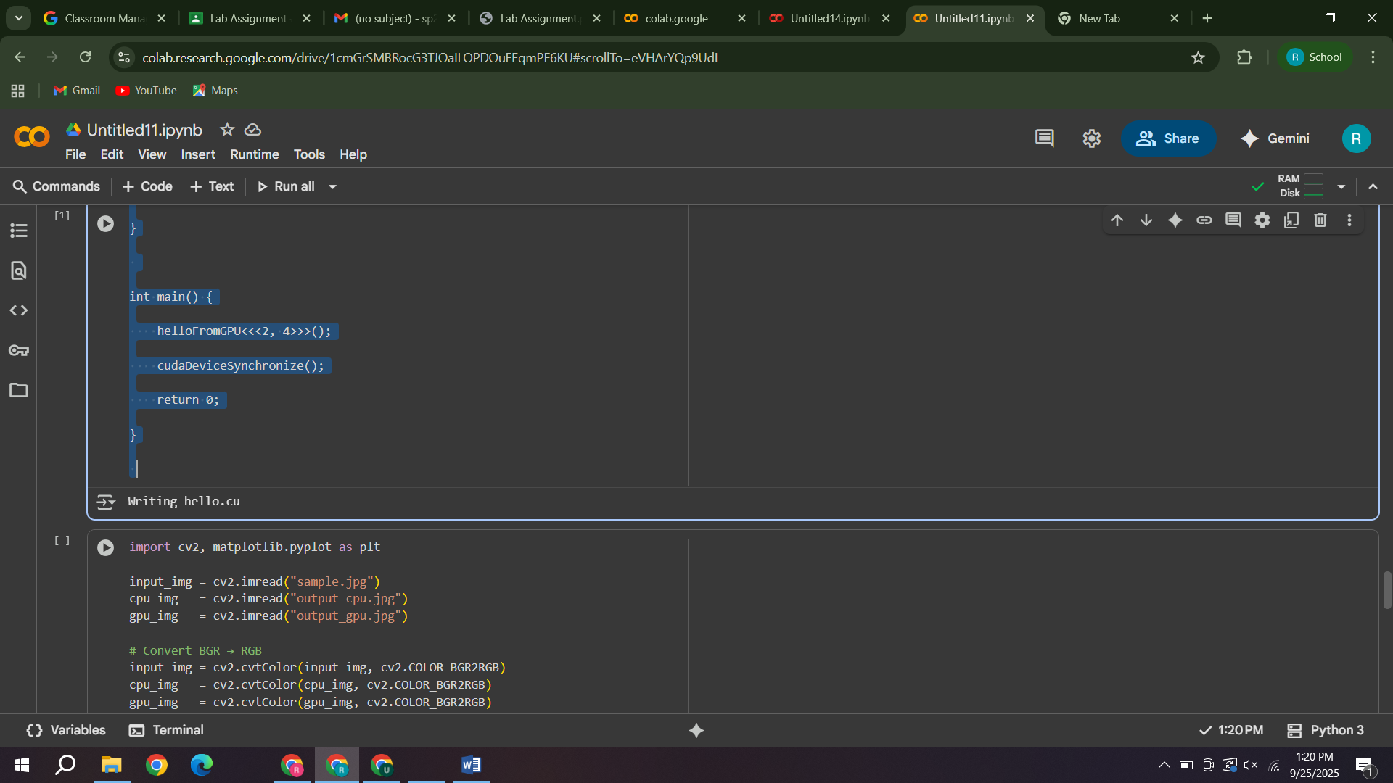

**Part 2: Vector Addition (CPU vs GPU)**

**• Implement vector addition of two large arrays (e.g., 10 million elements):**

**o First on CPU (normal C++ loop).**

**o Then on GPU (CUDA kernel).**

**• Measure the execution time of both.**

**• Calculate the speedup ratio:**

**Speedup=CPU TimeGPU Time\text{Speedup} = \frac{\text{CPU Time}}{\text{GPU**

**Time}}Speedup=GPU TimeCPU Time​**

%%writefile vector_add.cu

#include <stdio.h>

#include <cuda.h>

#include <chrono>

#include <iostream>

using namespace std;

__global__ void vectorAdd(float *A, float *B, float *C, int n) {

    int i = blockIdx.x * blockDim.x + threadIdx.x;

    if (i < n) {

        C[i] = A[i] + B[i];

    }

}

int main() {

    int n = 10000000;  // 10 million

    size_t size = n * sizeof(float);

    float *h_A = new float[n];

    float *h_B = new float[n];

    float *h_C = new float[n];

    for (int i = 0; i < n; i++) {

        h_A[i] = 1.0f;

        h_B[i] = 2.0f;

    }

    auto start_cpu = chrono::high_resolution_clock::now();

    for (int i = 0; i < n; i++) {

        h_C[i] = h_A[i] + h_B[i];

    }

    auto end_cpu = chrono::high_resolution_clock::now();

    double cpu_time = chrono::duration<double>(end_cpu - start_cpu).count();

    float *d_A, *d_B, *d_C;

    cudaMalloc((void**)&d_A, size);

    cudaMalloc((void**)&d_B, size);

    cudaMalloc((void**)&d_C, size);

    cudaMemcpy(d_A, h_A, size, cudaMemcpyHostToDevice);

    cudaMemcpy(d_B, h_B, size, cudaMemcpyHostToDevice);

    int threadsPerBlock = 256;

    int blocksPerGrid = (n + threadsPerBlock - 1) / threadsPerBlock;

    auto start_gpu = chrono::high_resolution_clock::now();

    vectorAdd<<<blocksPerGrid, threadsPerBlock>>>(d_A, d_B, d_C, n);

    cudaDeviceSynchronize();

    auto end_gpu = chrono::high_resolution_clock::now();

    double gpu_time = chrono::duration<double>(end_gpu - start_gpu).count();

    cudaMemcpy(h_C, d_C, size, cudaMemcpyDeviceToHost);

    printf("CPU time = %f sec\n", cpu_time);

    printf("GPU time = %f sec\n", gpu_time);

    printf("Speedup = %f\n", cpu_time / gpu_time);

    cudaFree(d_A); cudaFree(d_B); cudaFree(d_C);

    delete[] h_A; delete[] h_B; delete[] h_C;

    return 0;

}

**Part 3: Image Inversion (CPU vs GPU)**

**• Load an image (e.g., PNG or JPG).**

**• Implement pixel inversion:**

**new_pixel=255−old_pixel\text{new\_pixel} = 255 -**

**\text{old\_pixel}new_pixel=255−old_pixel**

**• Do it once using a CPU loop, and again using a CUDA kernel.**

**• Compare performance and verify that the output images are identical.**

%%writefile image_invert.cu

#include <opencv2/opencv.hpp>

#include <iostream>

#include <cuda_runtime.h>

using namespace cv;

using namespace std;

__global__ void invertImage(unsigned char* input, unsigned char* output, int width, int height, int channels) {

    int x = blockIdx.x * blockDim.x + threadIdx.x;

    int y = blockIdx.y * blockDim.y + threadIdx.y;

    if (x < width && y < height) {

        int idx = (y * width + x) * channels;

        for (int c = 0; c < channels; c++) {

            output[idx + c] = 255 - input[idx + c];

        }

    }

}

int main() {

    Mat input = imread("sample.jpg");

    if (input.empty()) {

        cout << "Error: Could not open image!" << endl;

        return -1;

    }

    int width = input.cols;

    int height = input.rows;

    int channels = input.channels();

    int img_size = width * height * channels;

    unsigned char* h_input = input.data;

    unsigned char* h_output = new unsigned char[img_size];

    // CPU inversion

    for (int i = 0; i < img_size; i++) {

        h_output[i] = 255 - h_input[i];

    }

    Mat cpu_img(height, width, CV_8UC3, h_output);

    imwrite("output_cpu.jpg", cpu_img.clone());

    // GPU inversion

    unsigned char *d_input, *d_output;

    cudaMalloc((void**)&d_input, img_size);

    cudaMalloc((void**)&d_output, img_size);

    cudaMemcpy(d_input, h_input, img_size, cudaMemcpyHostToDevice);

    dim3 block(16, 16);

    dim3 grid((width + block.x - 1) / block.x, (height + block.y - 1) / block.y);

    invertImage<<<grid, block>>>(d_input, d_output, width, height, channels);

    cudaDeviceSynchronize();

    cudaMemcpy(h_output, d_output, img_size, cudaMemcpyDeviceToHost);

    Mat gpu_img(height, width, CV_8UC3, h_output);

    imwrite("output_gpu.jpg", gpu_img.clone());

    cudaFree(d_input);

    cudaFree(d_output);

    delete[] h_output;

    cout << "Done: output_cpu.jpg and output_gpu.jpg generated" << endl;

    return 0;

}

import cv2

import matplotlib.pyplot as plt

# Load images

original_img = cv2.imread("sample.jpg")

cpu_img = cv2.imread("output_cpu.jpg")

gpu_img = cv2.imread("output_gpu.jpg")

# Convert BGR to RGB for proper color display

original_rgb = cv2.cvtColor(original_img, cv2.COLOR_BGR2RGB)

cpu_rgb = cv2.cvtColor(cpu_img, cv2.COLOR_BGR2RGB)

gpu_rgb = cv2.cvtColor(gpu_img, cv2.COLOR_BGR2RGB)

# Display side-by-side

plt.figure(figsize=(18,6))

plt.subplot(1, 3, 1)

plt.imshow(original_rgb)

plt.title("Original Image")

plt.axis("off")

plt.subplot(1, 3, 2)

plt.imshow(cpu_rgb)

plt.title("CPU Inverted Image")

plt.axis("off")

plt.subplot(1, 3, 3)

plt.imshow(gpu_rgb)

plt.title("GPU Inverted Image")

plt.axis("off")

plt.show()

